

Game Design Document

for a VR Escape Room

Basement Of Death

August 2024

Annabelle Pek

Confidential Disclaimer
This Game Design Document has been prepared for review by (Name). All information is confidential and proprietary and should not be shared without written permission.

Overview of the Game
Genre:
Horror, Puzzle Solving, Escape Room, Single Player
Inspirational references:
Outlast, Resident Evil, Fears to Fathom - Ironbark Lookout

Basic Narrative:
Setting:
The game is set in rich mansion of a billionaire, Jeffrey Campbell. The mansion has hidden basements and secret rooms, filled with macabre surprises and dangerous traps.
Prologue:
The protagonist, Shane Lambert, is an elite spy hired to infiltrate the mansion and steal a priceless artifact rumoured to hold secrets worth millions. The mission goes awry when Shane triggers a hidden trap, leading to capture.
Act 1: Captured and Trapped (Example)
- Shane wakes up in a dark, bloodstained basement, disoriented and chained to the wall.
- Shane must escape the restraints and explore the immediate surroundings to find a way out.
- Solve a series of clues left by previous captives, leading to the discovery of a hidden key to unlock the chains.

Inspirational art:
1. https://www.ign.com/wikis/outlast/Outlast-_Know_All_Guide
2. https://residentevil.fandom.com/wiki/Operating_room
3. https://steamdb.info/app/2506160/screenshots/
4&5. https://www.gamepressure.com/cyberpunk-2077/the-hunt-river/z3dfcf
6&7 .https://www.gamepressure.com/alien/access-the-project-kg348-research-labs/zf6a26

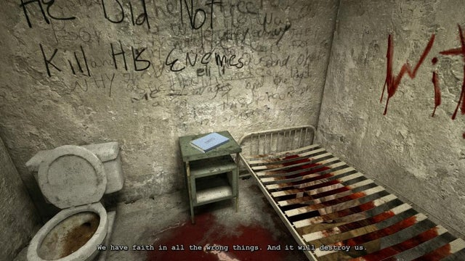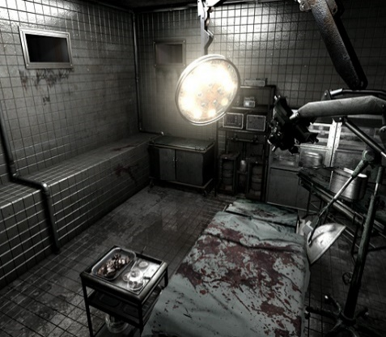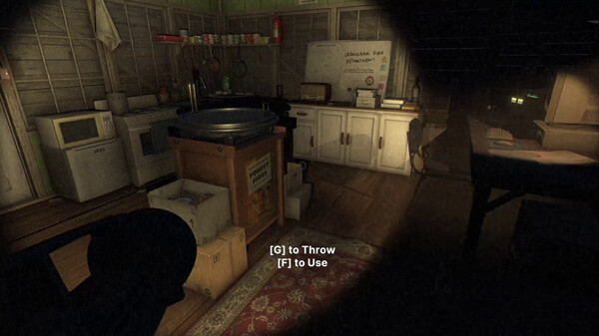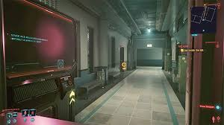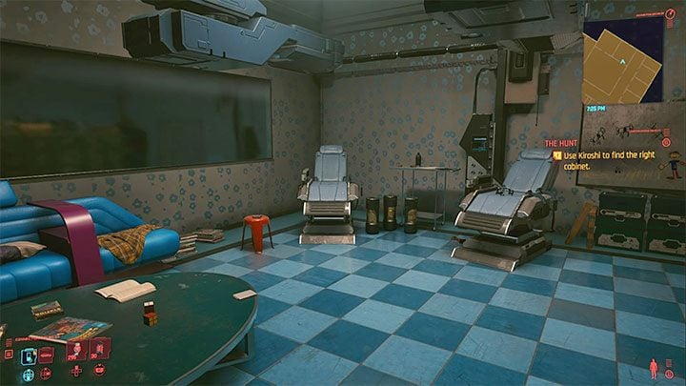

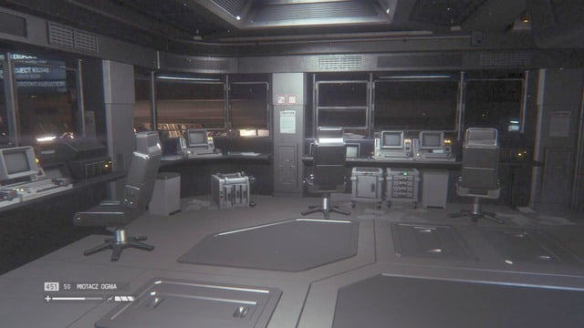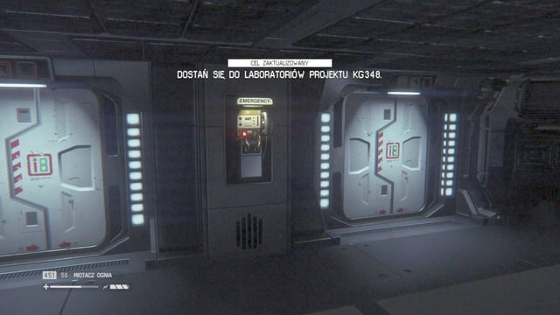
Unique Selling Points
- Chilling experience filled with surprises and unexpected dangers
- Solve puzzles, challenging players' wits and making the gameplay even more engaging
- Discovering the dark secrets behind Jeffrey Campbell's estate and its connection to Shane Lambert as players explore
- Well-developed characters and a mysterious plot that unfolds through exploration and discovery
- Frightening atmosphere with detailed settings and dynamic lighting when in the basement

Game loop

How will the player move throughout the game? What is the locomotion style?

The primary locomotion method will be a "teleportation" system, allowing the player to quickly move between predetermined waypoints throughout the basement. By aiming and pressing a button, the player can teleport to a new location, helping to mitigate potential VR motion sickness.

What are the details of each puzzle or task?

1. Unlock the cabinet
Task: Unlock cabinet.
Details:
Shane wakes up in a bloody and dirty room. Where Shane will see a hairpin, on the top of a shelf, where they will have a paper on the table, about how to open lock using hairpin, where Shane needs to use the hairpin, to open the cabinet near him, and he will get the next clue about puzzle 2. Where the paper look like that:
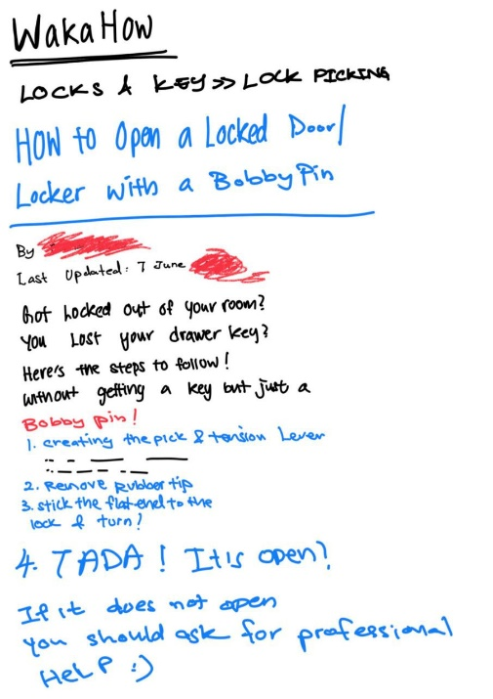

2. Get out of the room
Task: Open the door of the room.
Details:
Shane will get a clue of a paper, about the passcode near the door, where he has to solve normal things human know.
Number of months in a year: 12.
Number of legs on a spider: 8.
Number of primary colors: 3 (red, blue, yellow).
Number of vowels in the English alphabet: 5 (a, e, i, o, u).
Thus, the number sequence is 12835.
This is like a check if Shane is a human or AI, where Shane key in the right code and enter, the door will auto open it.
Solving this puzzle provides a hint for the next challenge and reveals part of Shane's past, such as a paper stating his designation, "Human_AI_920." (920 is also Shane birthday, 0920)
Where Shane will be surprise that he is actually an AI, even though he get that code right, which means that he is an AI with no error. Then Shane will go in a hallway and enter a lab.
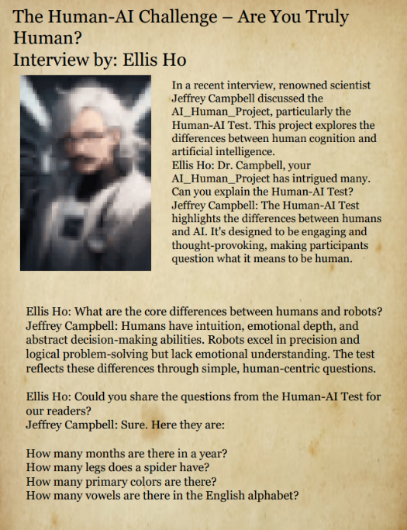
(this puzzle is to solve the keypad of puzzle2)

Solving this puzzle unlocks a hidden compartment containing a hint for the next puzzle, along with another piece of Shane's backstory, revealing his connection to the mad scientist and the experiment that created him.

3. Creepy Doll Puzzle, chest puzzle
Task: Interact with the creepy doll to reveal a hidden clue.
Details:
The creepy doll in the room holds a secret. Players need to examine the doll closely and might need to manipulate it, like press a button, pull a lever, to reveal a hidden compartment or a key tucked inside the doll. This clue will provide essential information for the next puzzle and another piece of the narrative, revealing a disturbing aspect of the experiments performed by the mad scientist. Where the clue of pressing button or switch, is written on a note, which is paste on the pc behind the chest.
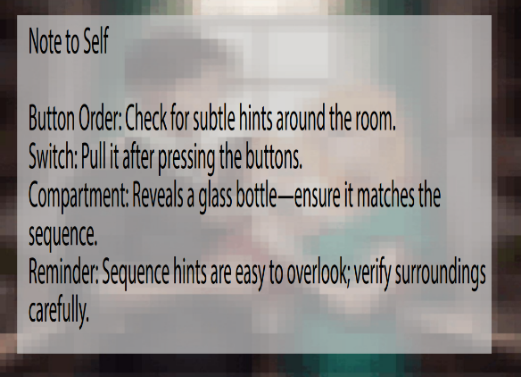
Where in this background, show a family of 3, where is Jeffery’s family.
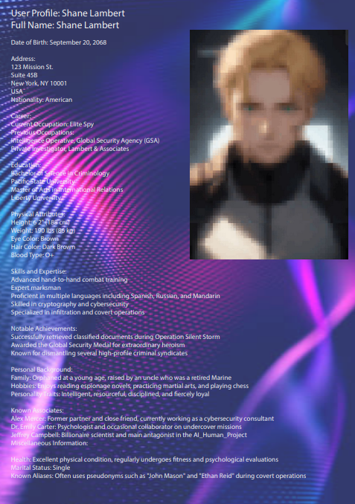
If player is lucky enough to find this clue, they will realise that Shane has a blonde hair and have a mark on his face.

4. Sorting of test tube.
Where after puzzle 3, player will be opening a box, where it will have a paper, showing a poem, where the colour of the test tube to place in order, where player is able to sort the test tube at the other table, after sorting and placing the table correctly, the button beside the door will be open as the button is activated. Where they click the button, it will open the final door of the puzzle.


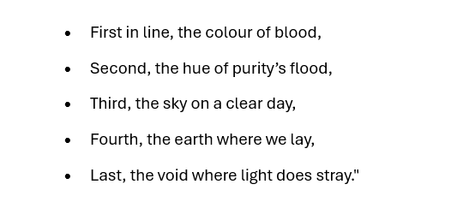
Red, White, Blue, Brown, Black

So Player might can get the full story from this and the Shane report, where Shane is most likely to be Jeffery’s son, which the son is injury and Shane is in an orphanage, and the uncle is more likely to be Jeffery’s people, where reason of why Jeffery have his son in orphanage, as Jeffery is working on an AI_Human project, where most likely that he start this as his son is not being able to be fully active in his brain, where they are able to get this information from puzzle 2 clue, where player might not be able to full understand the storyline in one go as the clue are not together, however, if they play a few times, with that human doll, player will know that Jeffery is a mad scientist and billionaire where work so hard on AI_Human. As Jeffery’s wife, Ava, is dead but Jeffery still wants to try something to make Ava alive again.

Gameplay Scope
How long is the game?
- Around 2-3 hours, so it an average game time.
How many levels are there?
- 4 levels, 4 puzzle
What is the average playtime?
- 20 – 35 minutes per level, where include the reading of puzzles and solving
What are the objectives?
- The player, who act as Shane Lambert, have to escape the basement after being caught by the traps, where as player solve the puzzle, they will be revealing the past of Shane and the dark story.
How many playable characters? Can you customize or upgrade them/what can you customize or upgrade?
- Single playable characters, however, the player can customize what Shane Lambert wear.

Art Style
Include a description of your art style and supplement it with art concepts or inspirational concepts. Describe your style for the environment, characters, UI, etc. You can also link to a different area it lives in.

The game will be design and create a chilling atmosphere which will show horror elements in the game, where the environment will be giving a creepy and mystery feeling, using dark colours and using detailed textures and dim lighting, will create a horror, scary feeling. Shane Lambert, the character, will be giving a mystery feeling as he is a spy, and dark feeling, showing unknown. The UI will be ease of interaction and able for the player does not feel so odd when they do the puzzle solving.

Concept Art:
- https://x.com/HugoRichard_art/status/1668288259175202816
- https://tvtropes.org/pmwiki/pmwiki.php/Characters/ResidentEvilLeonSKennedy

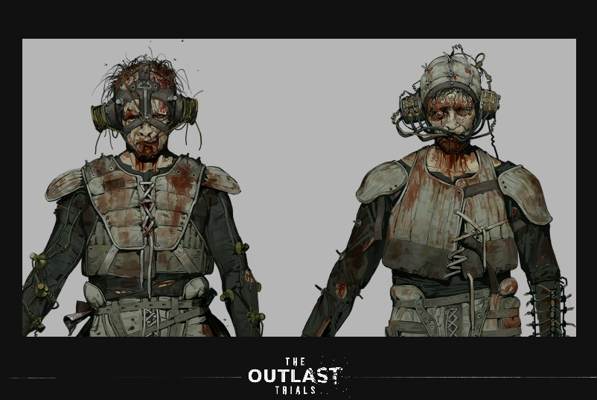

Examples of my UI design (menu):
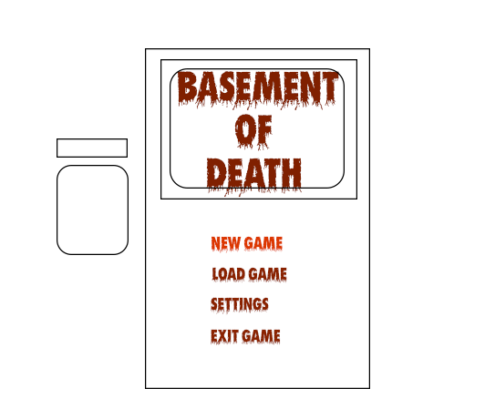

Flowchart
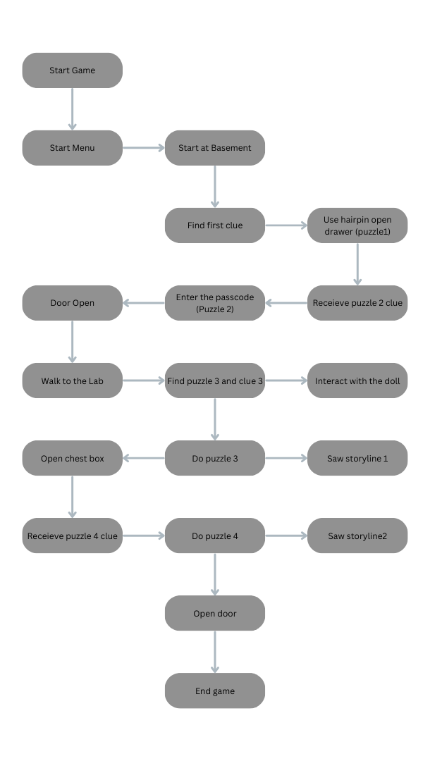
Storyboard
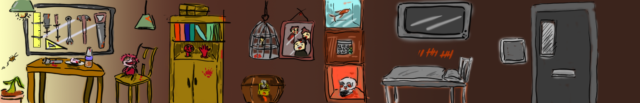

Player Profiles Stories

Alex – Puzzle Player: Alex will be interested in puzzle solving, as it will be challenging, where Alex needs to be creative and observe the environment to solve the puzzle. Where he needs to use logical thinking to solve the puzzle and cracking the puzzles and getting into the game as he solves the puzzle. Alex will be engrossed in the puzzle solving and explore the room and feel accomplishment after solving the puzzles and unlock new area and puzzle.

Ellis – Horror game lover: Ellis love horror games, where this game will be scary as the game has horror elements and she will be loving the scary items, environment and story, where she will be loving to find out the dark story inside the game. She will feel the fear of the horror elements and seeking the most scare moment of the game, spine-chilling sound effect and jump scare, might let her feel excited and uncovering the dark story behind Shane Lambert will give her adrenaline rush.

Sam – Story gamer: Where Sam will be in love with the story of the game, as they will be uncovering the background of Shane Lambert, where they will be exploring and interacting the environment storytelling, fully into the game. He will be deeply invested in the game story as he finds the clues and details of the story, and able to understand the story after collecting the clues and group it up to understand the story fully. Where he will experience the feeling of Shane Lambert and feel the story and emotion and understanding the story.

Milestone Schedule
1: Planning of game: (End of May 2024 – 25 May 2024 – 30 May 2024)
- Finalize and decide the game design document
- Complete game design document
- Define what theme and features
- Define how the game story be like
- Outline the main plot of the game
- Develop Character story
- Type of art will be shown in the game
- Create of concept art
- Decide on visual style

2. Prototyping of the game: (2 June 2024 – 18 June 2024)
- Developing of the game environment
- Basic environment design and level design
- Designing the item being used in the game
- Design items, intractable items
- Ensure it suit the game
- Create first puzzle – chain puzzle
- Design of the first puzzle for test run

3. Developing of game: (19 June 2024 – 15 July 2024)
- Create the 2nd, 3rd and 4th puzzle
- Develop the puzzles
- Make sure it is harder as it goes
- Sound effect
- Adding sound effect (creepy background music)
- Matching the game theme
- Character design
- Designing the character outfit, looking

- Testing first version: (16 July 2024 – 20 July 2024)
- 4th puzzle
- Complete the puzzles while checking for error
- Ensure the puzzles are solving and working fine
- Test for bug fixing
- Bug fixing for the game
- Ensure that the game will be smooth in gameplay
- Conducting bug fixing based on testing and feedback
- Ensure that the game work fine
- Ensure that the item should be working properly
- No weird item should be moving when the player did not move it

5. Final version of game: (21 July 2024 – 1 August 2024)
- Complete the puzzles and testing no error
- Finalize the version and making sure the puzzle work fine
- Eliminate the bugs
- More bug fixing of the game
- Focus on user experience when playing
- Polish the game
- Ensure that the story flow well
- Review the entire game to ensure that the player will understand the story as they play
- Make some small adjustment to ensure the story flow well

